390 Mini-Project

Team 3

Tom Heysel – 20000838 – 15tjh2@queensu.ca

Thomas Downs – 20024522 – 16td1@queensu.ca

Dennis Grajo – 20017666 – 15dlg3@queenus.ca

March 5, 2019

# Section 1

The team brainstormed a comprehensive list of possible applications for a smart chair by drawing from current market usage and new ideas. The following sections categorize the results from the ideation session.

## Healthcare

Possible applications for smart chair technologies were identified and grouped together based on their usefulness in assisting people with health conditions or limited mobility. This application focuses on assisted motion with hands free capabilities, sensors to monitor health and wellbeing, and in the case of emergency, call capability.

A smart chair outfitted with wheels and controlled using voice controls or an easily accessible control mechanism, such as a joystick, could grant these people the mobility that they may not have had before. Another benefit is that through these proposed control mechanisms, they do not need to push the wheels on the chair themselves nor do they need an assistant to push the chair for them, providing the user the freedom to move as they please.

Other mobility applications could incorporate assisted sitting and standing. With motorized hinges and weight sensors, the chair could aid the user from going from standing to a comfortable sitting position and vice versa in a safe and controlled manner.

With Ballistocardiographic (BCG) sensors installed in the chair, it could be used to monitor heart and breathing rates, which can be used to detect irregular bodily conditions. By detecting anomalies in the user, the chair can vibrate to alert the user, so that they may take the necessary measures to deal with the problem before it intensifies, or in the case of an emergency send a message to alert someone else, so that they may be able to come and provide assistance.

Other health considerations include monitoring the surrounding environment – such as the humidity or the temperature of the room they are in. It can then either alert the user so that they may change the chair’s heating or cooling themselves, autonomously change them to the appropriate levels, or, use WiFi and the IoT to change the room’s heating and cooling.

## Leisure and Relaxation

A group of possible applications for smart chair technologies were grouped together due to how well they enhanced leisurely activities and relaxation. The focus of this application is optimizing the user experience. Some examples of improving the UX design are giving the chair the ability to augment the user’s environment with limited input, implementing headrest audio speakers, allowing the use of voice-controlled commands, and improving the overall aesthetic of the chair with lighting features.

With temperature sensors taking frequent readings, heating components can be activated to warm up the seat or turn on a fan to provide a comfortable experience for the user without the need of any user input. The temperature sensors on the chair can detect the surrounding temperature to determine the appropriate heating/cooling on the chair for the maximum amount of comfort for the user.

Another example of improving the user experience is designing the chair with headrest speakers and a voice-controlled interface. By implementing a hands-free interface, the user can casually change the settings of the chair to cater to their needs, like playing music, reclining the seat, turning the heaters on or off, etc.

When it comes to recreational PC users, especially gamers, they generally want their peripheral setup to match or look aesthetically pleasing. By including lights that can be set to any colour, it allows the user to match the colour scheme of their other peripherals. This doesn’t necessarily solve a problem, but the look of the chair will be important to a lot of possible customers if designed for recreational or leisurely activities.

## Office

A different group of applications for the smart chair were grouped together due to the benefits they provide in the office space. This category focuses largely on increasing productivity through smart technologies and ergonomics.

Through the use of the built-in sensors, the smart chair can detect poor posture and change its shape to provide the optimal ergonomic position for the user. This system could be used to reduce strain on the users back and wrists and in doing so enhance the productivity of workers [1][2].

Another application that the smart chair could be used for around the office would be making calls or sending messages using the smart chair’s built in communication technology. Rather than using a phone to call or send a quick message, the user can just use their voice to command the smart chair to contact someone for them.

Having the chair linked wirelessly to the user’s phone, the seat could function as an assistant, vibrating when important events are coming up, or turning on different lights in the chair to signal to other workers not to disturb during an important phone call.

# Section 2

The team decided to take a deeper look into how the chair can benefit those in an office environment. Since office workers spend countless hours sitting in front of a desk every week a proper sitting posture is integral to their well-being, and their level of comfort can be directly correlated to their work productivity. Therefore, the major problem that could be solved using smart technologies is reducing physical strain that stems from people having poor posture.

The team considered how this technology could be extendable to other users (such as students), however, office workers were deemed to be the most likely benefactor as they are generally sitting in the same seat every day, and for longer periods of time than students.

While the health benefits of the smart technology will be felt by the individual user, it is important not to forget that the business as a whole will be affected by the increase of productivity. Therefore, the managers, customers, and shareholders of the company would all get benefits from investing in smart chairs.

Furthermore, manufacturers, material producers, and other production line elements will benefit from the work established from the building of the products.

# Section 3

Interviews were conducted via an online survey. Although the identities of the survey participants were kept anonymous, the team attempted to select people from a range of ages and lifestyles, to attempt to prevent sampling bias. The following is a summary of the meta data collected from the participants.

Table Survey 1 Meta Data

|  |  |  |  |
| --- | --- | --- | --- |
| Participant | Age | Gender | Hours Sitting per Day |
| 1 | 20 | F | 8 |
| 2 | 73 | M | 7 |
| 3 | 21 | M | 5 |
| 4 | 37 | F | 6 |
| 5 | 40 | F | 2 |
| 6 | 53 | M | 6 |

## Questionnaire

The following is the questionnaire that the participants were presented with

1. Who is mostly to use a smart chair? (Elderly/Disabled, Office Workers, People Seeking to Relax).
2. What problems do these people experience that would make them benefit from a smart chair? (Open Ended).
3. What possible features of a smart chair can you think of? (Open Ended).
4. What current solutions are available for this target audience? (Open Ended).
5. What is lacking with these current solutions? (Open Ended).
6. How could a smart chair help them with their problems? (Open Ended).
7. How much would you be willing to spend on a smart chair? (0-50, 50-150, 150-300, 300-500, 500+).

## Response Summary

Note that most of the questions in the team’s survey had open ended responses. Despite this, a surprising number of answers came back the exact same. In the cases where this occurred responses have been summarized and grouped into similar categories.

#### Question 1 - Who is mostly to use a smart chair? (Elderly/Disabled, Office Workers, People Seeking to Relax)

The first question’s responses were divided equally with 50% of respondents stating Office Workers would get the most benefit out of a smart chair, and the other half stating People Seeking to Relax.

#### Question 2 - What problems do these people experience that would make them benefit from a smart chair? (Open Ended)

Responses for the second question are modelled in the pie chart below, with the highest occurring need for a smart chair being discomfort due to sitting for long periods of time. This response was recorded 3 times.

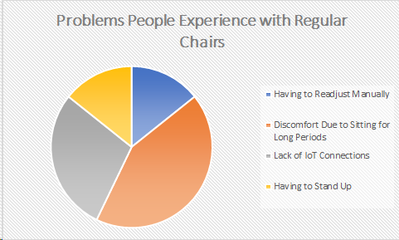

Figure Survey 1 Question 2 Summary

#### Question 3 - What possible features of a smart chair can you think of? (Open Ended).

The third question resulted in a wide spread in suggested features, with frequent overlap between respondents. The highest mentioned feature was memory capabilities for position settings and occurred 3 times.

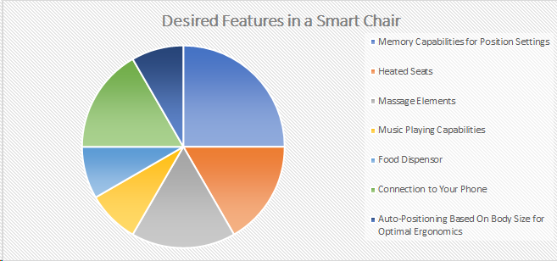

Figure Survey 1 Question 3 Summary

#### Question 4 - What current solutions are available for this target audience? (Open Ended)

Question 4 was interesting as every single respondent said that there are no current solutions for the target market. This indicates that there may be a gap in the market for the project to fill. There were some helpful insights with 2 respondents suggesting designs could be based off the smart capabilities of car seats, and 2 suggesting them to be based off massage chairs.

#### Question 5 - What is lacking with these current solutions? (Open Ended)

Question 5 was the first not to have any overlap between participants answers. The following is a summarized response from each of the participants:

1. Car chairs have a limited number of memory slots for position settings
2. Car chairs lack the precision and convenience in memory slots for position settings
3. Massage Chairs are too highly specified
4. Massage chairs lack enough features to be worth the cost
5. Regular office chair lack any form of intelligence
6. Regular office chairs are not customizable

#### Question 6 - How could a smart chair help them with their problems? (Open Ended)

The sixth question asked respondents to identify areas that smart chairs could help with their problems. Their answers are depicted in the pie chart below.

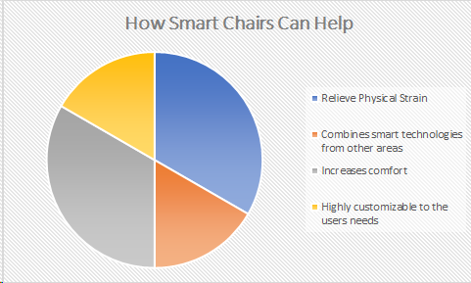

Figure Survey 1 Question 6 Summary

#### Question 7 - How much would you be willing to spend on a smart chair? (0-50, 50-150, 150-300, 300-500, 500+).

Lastly, we asked how much the respondents would be willing to pay for a smart chair, 1 person responded $50-150, 2 answered $150-300, 2 thought they would pay $300-500 and the last said $500+.

### Survey Analysis

Based on the response from the user study, most participants believe the problem to be that sitting for long periods of time can cause discomfort in the short term and physical strain in the longer term. Therefore, the main issue arises from health considerations due to the large number of hours spent seated.

After analysis of the response, we conclude that existing solutions are not good enough because they are largely non-existent for the target users. Regular chairs are unable to autonomously adjust themselves to fit the user’s ergonomic and leisurely needs. Features in car seats and massage chair exist but are not found in common environments, such as in the office or living room. By integrating their features into one product, the benefits from both can be found in one easily accessible chair. Due to the lack of current solutions, it is believed that this new smart chair will fit into a gap in the market, making it a good project to investigate further.

# Section 4

## Concept 1

Concept one is an office chair and accompanying app to control the position individual height, recline, and additional features such as back massage, heated seats, headrest speakers, and a neck fan. The app allows you create an unlimited number of preset position and feature modes or control the settings freely through the app’s easy to use position sliders.

Table Concept 1 SWOT Table

|  |  |  |
| --- | --- | --- |
| Concept 1 | Helpful | Harmful |
| Internal | Highly customizable.  Accessible interface.  Saves your custom settings on the phone - portable. | Expensive to produce  Many moving parts (feature creep)  Difficult repairs  Potential fire hazard (heated seats)  Requires power connection |
| External | Universal design (Android and IOS)  Improving posture improves productivity | Difficult purchase to justify  Unknown market  Expensive to purchase |

## Concept 2

Concept two uses embedded sensors throughout the chair’s base and back to create a profile of the user’s body shape and gradually adjust itself into the most ergonomic position for the user. This design focuses on unobtrusively training the user to adjust their posture over a long period of time to ultimately increase their work productivity.

Table Concept 2 SWOT Table

|  |  |  |
| --- | --- | --- |
| Concept 2 | Helpful | Harmful |
| Internal | Highly customizable.  Incredibly easy to use. | Expensive to produce  Requires complex machine learning  Requires power connection |
| External | Improving posture improves productivity.  Unique to each individual person. | Difficult purchase to justify  Unknown market  Expensive to purchase  Lack of transferability between users |

# Section 5

During the second round of interviews, the team compared the two solutions determine which parts users preferred, what can be changed to enhance the design, and what should be left out entirely.

## Questionnaire

1. Which concept solution do you like best?
2. What about this solution do you enjoy?
3. What parts do you think could be left out?
4. What is your favourite part of the other solution?
5. Would you mix any features of these solutions?

## Response Summary

Give the description of the concepts discussed in Section 4, the majority of interviewees responded to Q1 that they preferred Concept 1 over Concept 2 with a 60 - 40 ratio.

The results from Q2 are summarized and compared to those of Q3 in the two charts below. Although fan and heated seats were highly recommended in the first survey, potential users don’t see them to be a good fit in these designs. Additionally, although the massage feature was highly recommended, it comes last place in the desired features list. These give good insight into the difference between what users ask for, and what they actually want.

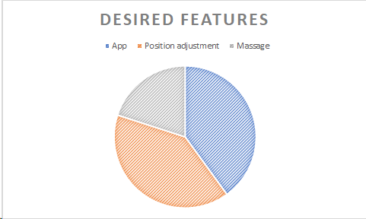

Figure Survey 2 Question 2 Summary

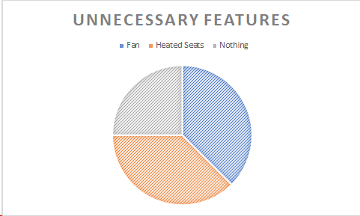

Figure Survey 2 Question 3 Summary

Question 4 asked the users to identify their favorite parts of the concept solution they did not select as their favorite. The summarized response was that users thoroughly enjoy the portability of the system through the app of the first solution, and the learning capabilities of the second.

When asked to provide a solution mixing the two solutions in Q5, 4 of the 5 respondents suggested using the two favorites of Q4, in one device.

# Section 6

Based on the second round of interviews, and the narrow split between respondents’ favorite concept, the team as decided that a mix of the two concepts is the best option. Although the massage chair, heated seats, and neck fan were highly recommended in the first survey, they were not recognized as useful contributions to the concept solution. Due to this response and the desire to reduce feature creep, the team has opted to remove these components from the design, going for a minimalist mix of the two solutions.

The MVP will resemble a modern office chair with low friction wheels and 360-degree swivel, its smart capabilities only noticeable by two small physical differences. The first is retractable power cable emerging from the base of the chair, the second, an unobtrusive button on the outside of the right armrest. This button allows for Bluetooth connection to a mobile phone via a free Android or IOS app. The app will allow users to connect to any chair, adopting a universal product model to enhance scalability. Upon downloading, the app will ask the user various questions about their body type. Using this information, it will adjust the vertical position, degree of recline and height of the armrests to form the most ergonomic shape for your body. This position will be saved in the app for ease of access. The app will also include an unlimited number of user defined position settings that to select and adjust to, or, control the position freely through the app’s easy to use position sliders.

# Section 7

After finalizing the designs for the MVP, our team reached out to 5 more potential users to determine if the project converges.

## Questionnaire

The following questions were posed to the participants. The four questions were written to target the MVP and determine where it falls short.

1. What do you not like about the current proposed solution?
2. What features do you think could be left out?
3. What reasons would you have to buy this product?
4. Are there any concepts about this product that confuses you?

## Response Summary

The results of the first question were placed in a pie chart and can be seen below. The biggest problem encountered with the current proposed solution is price – the interviewees found the product too expensive.

Figure Survey 3 Question 1 Summary

In response to the second question, most users found that there was nothing that could be removed from the system, a good sign that the MVP is converging and not over featured. The third question produced a variety of reasons for the interviewees to buy the product – the ability to control their chair settings with their phone, comfort, and the desire to fix their posture problems.

Figure 8 Survey 3 Question 3

Figure 7 Survey 3 Question 2

The fourth question’s results were not placed in a pie chart as there was no overlap between the responses. Instead, the individual results are listed below:

“How does the chair know what the proper way for me to sit is?”

“I don’t get the whole importance of having the perfect posture all the time”

“I’m confused with what would happen when a new person sits at ‘my’ chair”

The other 2 interviewees claimed that they were not confused about any aspect of the product and so their answers are not listed above. The remaining three points of confusion arise from a lack of understanding of how the product will be designed, and the research behind ergonomics. These two topics should be focus points during the advertising stage.

From the results of these four questions, it can be concluded that the design process undertaken in previous steps were converged to one best solution, and that the MVP is approved by the sample populations. From the second question, most people found that no more features can be removed from the product, a good indicator that the current MVP is as minimal as possible. However, consumers have raised the concern that the price may be too high to justify purchasing the product. The consumer’s price concerns are a vital point to ensure does not come to fruition in the remaining stages of design.

The next steps to do would be to create a prototype, with which to perform user studies. Using these user studies and the prototype, the team would pitch to potential investors and raise capital. Bringing the product to market, reviewing response, and further iteration would carry on indefinitely.

# Section 8

After a series of surveys, an MVP smart chair was designed with features that target improving health and productivity for the user. To get an idea of the target market for this product, the team researched the office furniture manufacturing industry.

The office furniture industry is a well-established and mature market, so introducing a new product isn’t likely to cause any large disruption. However, a successful proof of concept could help advertise the product by boosting discussion about the health risks, social impact, and ethics of long term sitting in the workplace.

According to market reports conducted by IBISWorld, the Canadian market for office furniture manufacturing was found to be worth approximately $4.5 billion in 2018, with 9.1% of that revenue to come from seating [2]. This gives a total addressable market of $409 500 000 for office chair manufacturing in Canada. Below is a diagram outlining the Canadian office furniture market.

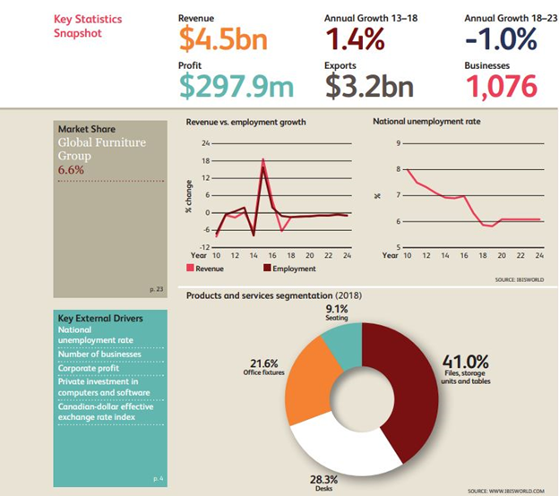

Figure IBISWorld infographic on the office furniture manufacturing market in Canada [2]

Most of the Canadian revenue comes from exporting goods, accounting for 71.2% of the total revenue. And of those exports, 95.7% of goods go to the United States.

Since the American market for office furniture manufacturing is very large and accounts for the majority of Canada’s revenue, the US market was also considered when finding the total addressable market for the smart chair [3]. The figure below outlines the United States’ office furniture manufacturing market.

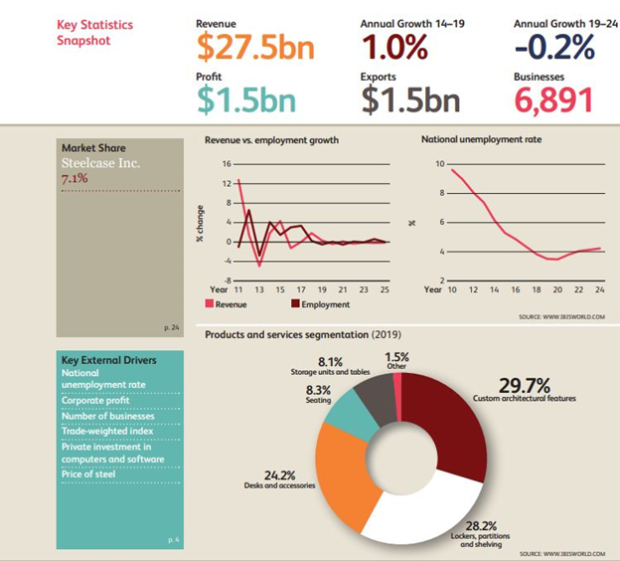

Figure IBISWorld infographic on the office furniture manufacturing market in the USA [3]

With seating estimated to account for 8.3% of revenue, and $27.5 billion in total revenue, the total addressable market for office chair manufacturing in the United States is found to be approximately $2.2825 billion [3]. Combining the total addressable market for the USA and Canada gives the final total addressable market of $2 692 000 000.

# Section 9

|  |  |  |
| --- | --- | --- |
| Section | Member | Role |
| 1 | All members | Brainstorming and categorization |
| 2 | Dennis | Stakeholder analysis and writing |
| 3 | All members  Tom H | Survey writing  Survey distribution and analysis |
| 4 | All members | Concept definition, SWOT table creation |
| 5 | All members  Tom D | Survey writing  Survey distribution and analysis |
| 6 | All members | MVP definition |
| 7 | All members  Dennis | Survey writing  Survey distribution and analysis |
| 8 | Tom D | TAM analysis |
| All sections | Tom H | Editing and compilation |

# Section 10 References

[1] S. Wang and J. Keating, "New smart chair technology to improve health of workers", *Monash University*, 2019. [Online]. Available: <https://www.monash.edu/news/articles/new-smart-chair-technology-to-improve-health-of-workers>.

[2] Gonzales, E. (2018). *IBISWorld Industry Report 33721CA: Office Furniture Manufacturing in Canada* (Rep.). IBISWorld

[3] McGinley, D. (2018). *IBISWorld Industry Report 33721: Office Furniture Manufacturing in the US*(Rep.). IBISWorld.